Cambridge International School Ceremony
School Name - Date

Programme

00:00 – Arrival

00:00 - Welcome address – School principal

00:00 - Speech by chief guest/sponsor

00:00 - Presentation of certificates

00:00 - Learner speeches

00:00 - Vote of thanks to the teachers of the subjects

00:00 - Refreshments
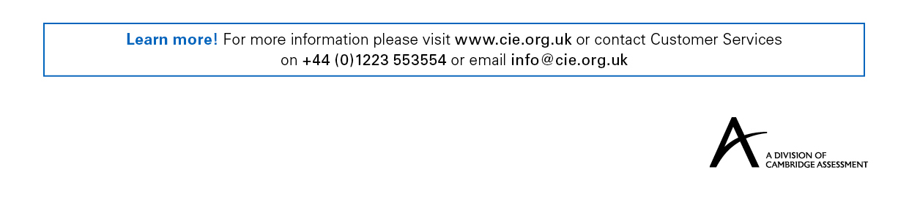
Copyright © UCLES 2017

